**3 Ways to Stay Optimistic During a Pandemic**

For 21-year-old Katie Johnson, the first two weeks of the stay-at-home order felt like a staycation of sorts. Furloughed from her job as a sales assistant, she completed homework for her newly-online classes, read that book she kept putting off, and applied more face masks than she cares to remember. She even bought a cat. But as months passed, she noticed that what seemed doable on day seven felt dreary after weeks confined in her basement apartment.

“I consider myself to be pretty upbeat. I hate to admit it, but as time passes, I find myself becoming more cynical. I keep wondering if life will ever go back to what I once considered normal,” said Johnson.

Johnson is just one of the millions of people affected by the COVID-19. According to a poll conducted by the Kaiser Family Foundation (KFF), [47%](https://www.kff.org/coronavirus-covid-19/issue-brief/the-implications-of-covid-19-for-mental-health-and-substance-use/) of those sheltering in place reported negative mental health effects resulting from stress associated to the coronavirus. The WHO has acknowledged the importance of mental health during COVID-19 on [their website](https://www.who.int/teams/mental-health-and-substance-use/covid-19), reiterating the importance of a healthy mind.

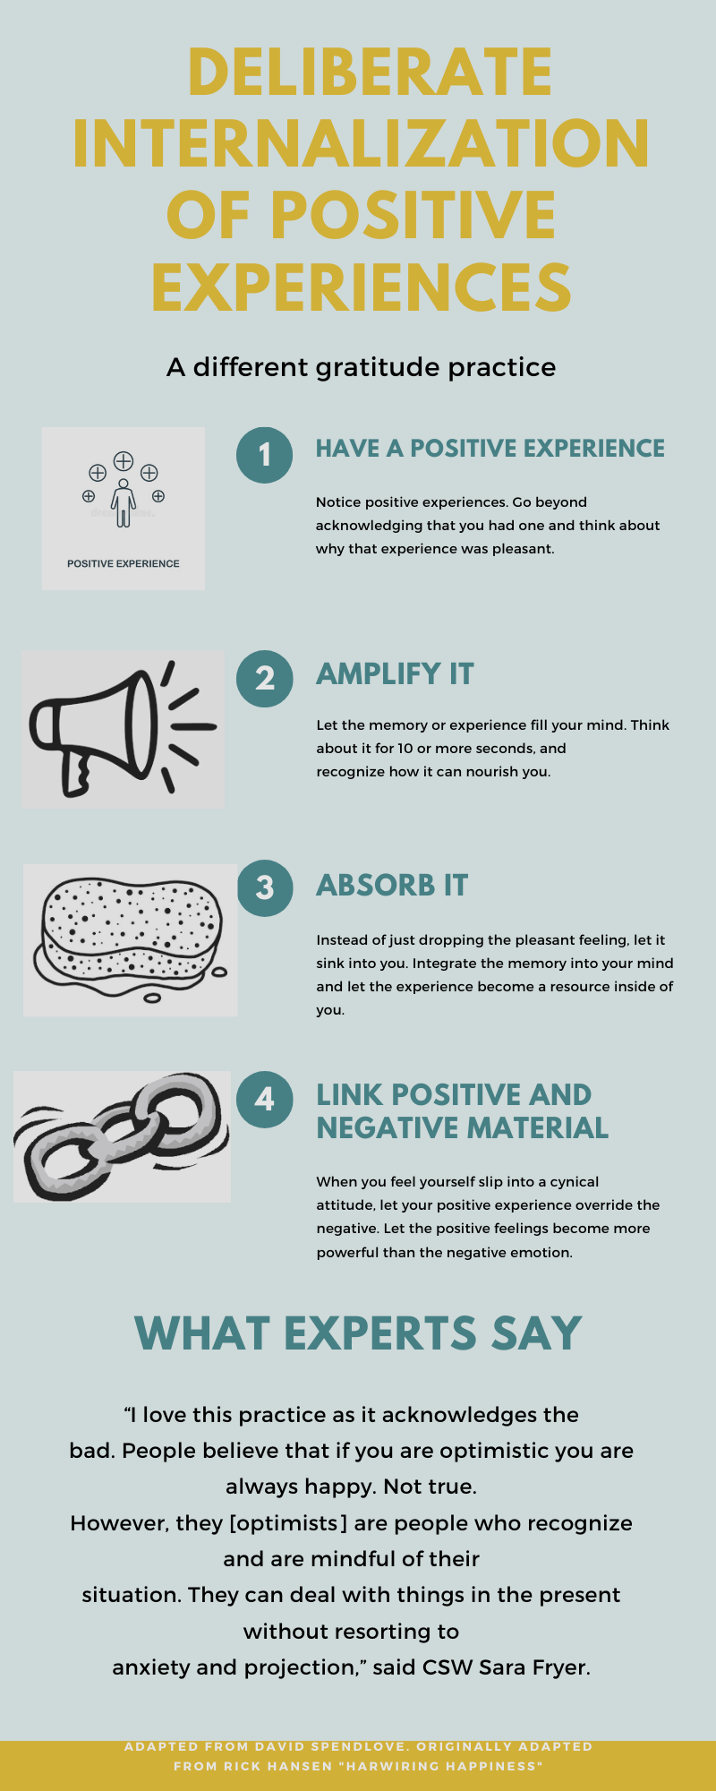 [Research](https://www.mentalhealthfirstaid.org/2019/02/5-surprising-mental-health-statistics/#:~:text=In%20the%20United%20States%2C%20almost,equivalent%20to%2043.8%20million%20people.) shows nearly half of all Americans will experience a mental illness in their lifetime. The coronavirus has exacerbated this problem, forcing people globally to confront a reality where schools are closed, jobs are lost, and loved ones are sick. According to [Tammy Luhby at CNN](https://www.cnn.com/2020/04/16/health/anti-anxiety-medication-us-demand-coronavirus/index.html), anti-anxiety medication prescriptions have increased 34% since March of this year. Experts are now realizing that mental health is not just an issue for people with disorders, but for everyone. For this reason, scientists are becoming interested­­­ in a newer area of study called optimism research.

Figure 1.1

This research shows that optimism has a profound effect on [resiliency,](https://www.researchgate.net/publication/336069494_Self-esteem_and_optimism_as_predictors_of_resilience_among_selected_Filipino_active_duty_military_personnel_in_military_camps) [life-expectancy,](https://www.npr.org/sections/health-shots/2019/09/01/755185560/optimists-for-the-win-finding-the-bright-side-might-help-you-live-longer) and [psychological well-being](http://www.koreascience.or.kr/article/JAKO201209640671515.page). As a newer area of research, it may contain fresh insights to getting you through COVID-19 quarantine. Plus, anyone can learn this skill. Here are 3 tactics to become more optimistic during this time of unprecedented fear and uncertainty.

**Foster Gratitude**

Oftentimes we associate the word gratitude with people saying “thank you” for gifts received or services rendered. In reality, gratitude is not simply an action, but an emotion, skill, and attitude. Exercising thankfulness can allow individuals to “acknowledge the goodness in their lives… As a result, gratitude helps people connect to something larger than themselves as individuals,” according to a letter by [Harvard Medical School](https://www.health.harvard.edu/newsletter_article/in-praise-of-gratitude). Gratitude compels individuals to look beyond their personal circumstances. Looking outside of your own problems allows you to find and acknowledge the good around you.

The practice of “giving thanks” does not always come naturally, but it’s not as elusive as you may believe it to be.

“Gratitude isn’t as difficult as we often make it out to be,” says PhD David Spencer. “It can be as simple as keeping a daily journal where you jot down a few moments that sparked appreciation. You don’t need to find a miracle to write about. It can be someone smiling at you, a moment of peace, or the fact that it was sunny outside during your lunch break. When my clients make a habit of noticing the good, they are surprised by the delightful moments they once took for granted.”

Writing’s not your thing? Check out figure 1.1 for an alternative way to incorporate gratitude into your life.

**Confront Cognitive Distortions**

You know those mean thoughts inside your head? Turns out we all have them. According to an article by [John M. Grohol, Psy.D.,](https://psychcentral.com/lib/15-common-cognitive-distortions/#:~:text=Cognitive%20distortions%20are%20simply%20ways,us%20feeling%20bad%20about%20ourselves.) “Cognitive distortions are simply ways that our mind convinces us of something that isn’t really true. These inaccurate thoughts are usually tied to reinforce negative thinking or emotions—telling ourselves things that sound rational and accurate, but really only serve to keep us feeling bad about ourselves.”

There are several types of cognitive distortions—apparently over 50. Before you rationalize your thoughts as always accurate you may want to check out [this article](https://www.psychologytoday.com/us/blog/in-practice/201301/50-common-cognitive-distortions) by Alice Boyce, PhD. In Psychology Today.

Naturally, cognitive distortions are a major optimism stumbling block. It’s hard to look on the bright side if you feel bombarded by negative emotions. Before you try and tuck them away though, CSW Sara Fryer suggests you confront them.

“Every time there is a situation there is a thought. From that thought there is an emotion and a behavior. So, if you are negative about the situation you are likely to be angry or depressed,” said Fryer. “But, if you change your thought, instead of reacting negatively you can take control of your emotions and become more proactive.”

The key to controlling your cognitive distortions is recognizing a thought for what it is. A thought. Don’t allow yourself to conflate thoughts with facts. Allow yourself the opportunity to reframe the situation in your mind by noticing if the thought benefits you in that instance. “If it doesn’t,” Fryer says, “Discard it and try to look at the situation from a different perspective.”

**Assess Your Support System**

Turns out emotions are highly contagious. Just like a cold moves through social networks contaminating people with sore throats and runny noses, peoples’ negative and positive emotions can alter the surrounding individuals’ moods.

Emotional contagion is so powerful that a [longitudinal analysis over 20 years](https://www.bmj.com/content/337/bmj.a2338) suggested that if a friend who lives relatively nearby (within a mile) becomes happy, those around them are 25% more likely to become happier too. So, if you surround yourself with optimistic people it becomes much easier to look at the bright side of things.

“It is important for clients to recognize the support system around them. A good support system can help you become more optimistic because there is someone holding you accountable and encouraging you to reach your goals,” said Fryer.

Unfortunately, negative emotions are just as contagious. Some experts even believe that negative emotions are spread faster given that people typically respond more strongly to negative events than positive experiences. That being said, it’s probably not possible to remove all of the “negative Nelly’s” in your life.

“We can’t dump all our friends. Often evaluating your support system is really practicing awareness. As humans, we like to blame our faults on others. By taking the time to analyze who we are happy and sad with, we often recognize our ability to affect others. Taking responsibility for our actions is a crucial step in creating the change we want to see in ourselves,” said Fryer.